食物包裝Food Packaging:
單張平版印刷指南
A Guide to Best Practice for Sheetfed Offset Print
Version: July 2013

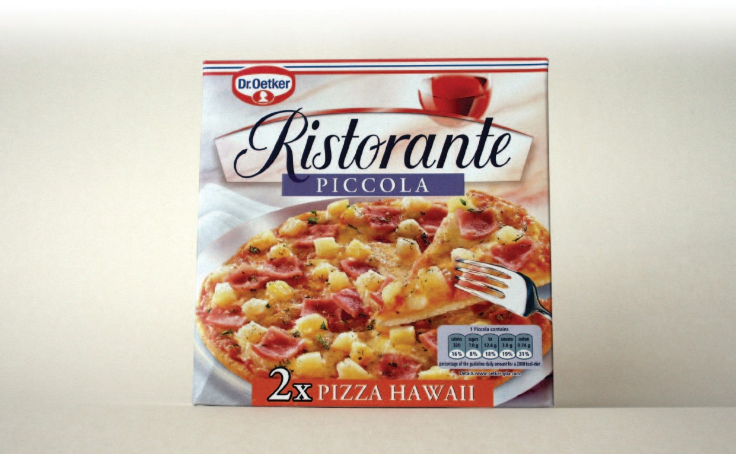
內容
- 主旨 2
- 食物與包裝設備的交互反應 (需注意的區域) 3
- 相關法律以及控制系統 5
- 預防印刷機跟轉換器對食物的汙染風險 7
- 常見問題 10

FlINT GROUP – 在全球市場致力於提供優秀的包裝跟標籤轉印機械

主旨

Flint 集團為致力於提供印刷、包裝以及標籤印刷解決方案的供應商。此手冊將以我們在此領域實務的多年經驗，提供給您食品包裝相關的規範綜覽。您將會了解到在包裝的過程，印刷機以及包裝轉印機和食品可能會有的交互作用。 我們將會帶您了解相關的法條，並且提供印刷時如何選擇油墨和食品包裝、以及打印食品標籤時的最佳建議。

食品包裝 – 敏感的議題

食品包裝是一個敏感的議題， 此領域的製造商必須要符合最高標準的製造流程來保護消費者權益。由於產品的特殊性，必然會有相當多的法律來規範包裝器材的原件和材料來保護包裝的食物，其中包含了產品標籤。所有在包裝設備供應鏈上的廠商都必須要確保，在食品包裝的過程，不會有任何傷害到末端消費者的情形發生，這之中包含了在食品包裝的過程中混入了不好的物質汙染食物。

2 | Food packaging: Best practice for print

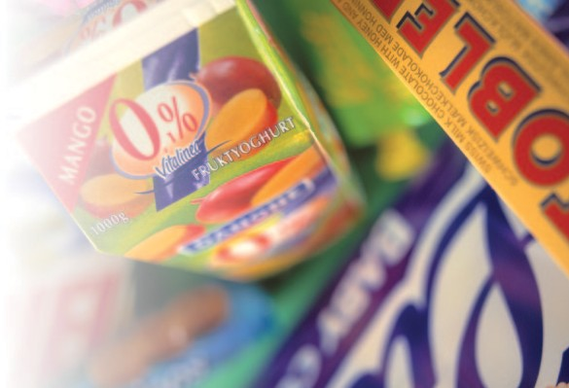

食物與印刷包裝的交互反應: 危險的領域

在食物與印刷包裝的過程，有三個主要會受到影響的範圍: 食品本身，食品的包裝，與其周邊，如下圖所示

外部 內部
轉移

滲入
食品

滲出

滲入

食物，包裝，以及周遭環境的交互影響

滲透作用 (Permeation)
滲透作用包含了任意物質穿過了食物的包裝外殼，無論是向內滲入或者向外滲出。環境條件的改變，比如說溫度變化，氣壓，或者濕度變化等等會加劇這樣的滲透反應。因此，在外部包裝上的物質或者周邊環境物質也有可能滲透到食物中。

遷移現象(Migration)
最主要的考量，就是物質從包裝上轉移到食物或者從食物轉移到包裝上的情形，因此食品包裝的材料(油墨、包材、夾層、標籤黏著劑等等)是需要嚴格控管的。以下的圖表說明了遷移現象的過程

食物
Substrate
油墨
膠印蹭髒
Through

食物接觸面 
遷移穿越區

遷移的主要形式
Migration of substance by set-off migration and by migration of ink components through the substrate

這些易遷移物質通常的法定濃度，依據濃度的大小，會以 毫克/公吋² (包裝大小)表示，或者毫克/公斤(食物重量)，有時也會以ppm(百萬分比濃度)表示，或是ppb(十億萬分比濃度)表示。這些殘留物也許不會有任何的氣味或者味道，但是可以用精密的化學分析儀器檢測出來。

常見的易遷移物質有:
 小分子物質 (<1000 道爾頓) 油墨, 膠 等等.
 印刷版物質
 塑料或是包覆物質
 化學清潔劑的殘留物，印刷殘留物，油汙等等

看不見的-蹭髒現象

雖然人眼也許觀察不到，油墨的蹭髒現象可能會在印刷品疊放時，導致印刷物質的反面遭到汙染。這可能會造成與食物接觸的包裝內側沾染到不良物質的風險。然而，遷移檢測以及最壞情況分析(Worst-Case Calculation)能夠量化這個情形的影響範圍。

典型的食物包裝範例，這之間有可能會有油墨以及包裝盒的內容物遷移到食物上

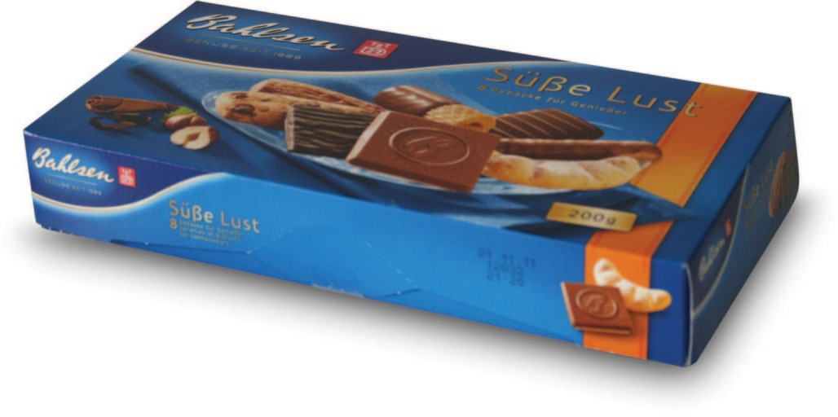

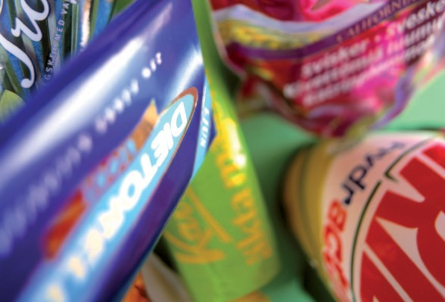
LEGISLATION AND CONTROL SYSTEMS

The long history of safe use of packaging demonstrates that existing controls are already effective in ensuring that the current products are fit for purpose, but it is sensible to review these. A number of common principles exist for the production of ‘safe’ food packaging, particularly in relation to migration issues.

Defining the principles

Firstly, responsibility for compliance of the packaging does not lie with one individual member of the packaging supply chain. It is owned by everyone concerned, including the printer, although ultimately it is the responsibility of those placing the pack on the market to ensure compliance.
A printing ink system can be safe for use on food packaging, or not, depending on the material it is printed on, the printing conditions, the food that is packed inside, the conditions during the packaging manufacture and filling, and the intended use of the packaging (deep freeze, ovenable, microwavable etc.). For these reasons the ink supplier alone can never take over responsibility for an ink being safe for any specific application.
Adulteration of food by the packaging or its component parts is not permissible; nor is any unacceptable change in the quality, odour, or taste caused by the packaging.
Migration of substances must remain below defined limits. Whether the packaging is safe with respect to migration can only be tested in the form of the final packaging arrangement.

Legislation of the European Union

Printing inks for food packaging are not directly covered by European legislation. There are, however, several regulations that are relevant to food packaging inks (see details in table page 6).
In principal all food packagings have to comply to the regulation EC No. 1935 of 2004 and especially article 3, about materials and articles which are intended to come into contact with food. Article 3 defines that food packaging is not allowed to transfer any substances to the food which could
  - endanger human health; or
  - bring about an unacceptable change in the composition of the food; or
  - bring about a deterioration in the organoleptic characteristics thereof.

Regulation (EU) Nr. 10/2011 relates to plastic materials intended to come into contact with foodstuffs. The Directive lays down an overall migration limit (OML) of 10 mg/dm² of surface area in respect to 60 mg/kg of baby food. In addition, specific migration limits (SML) or maximum contents in the material or article (QM) are set for individual substances. It also contains a positive list of monomers and other substances used in the manufacture of plastics intended for direct contact with food. Packaging inks that are not intended for direct food contact are not under the scope of this Directive. However, if there are components in the ink, which are listed, the relevant restrictions in this Directive, have to be observed. In order to support packaging manufacturers to comply with this Directive Flint Group provides information on the substances appearing in the Directive in a Statement of Composition.
The latest legislation affecting inks for food packaging is the Swiss Ordinance RS 817.23.21 from the Federal Office of Public Health, which came into effect on 1st April 2010. It requires that all inks used on food packaging must be composed of materials made from substances listed in the Ordinance. Flint Group, as a member of the European Printing Ink Association (EuPIA), has helped ensure that all companies supplying raw materials for printing inks have registered the respective materials.

North American legislation

In the United States the FDA regulates the materials which can be used in items (packaging) which will come into contact with food. There is a basic assumption that any materials used in food contact applications will become part of the food unless documented testing proves otherwise. The FDA provides a list of approved materials in title 21 CFR (Code of Federal Regulations). Inks and coatings that do not have direct food contact are not regulated; as long as there is a “functional barrier” between the food contact side and the ink or coating, and the inks and coatings do not migrate to the food contact side during various steps in the process. It is the responsibility of the packaging manufacturer to determine if the construction meets the definition of a functional barrier.

The prime general legal requirements

Region/Country | Relevant legislation | Main relevant aspects for the food packaging chain
European Union member states | Regulation (EC) No 1935/2004 of the European Parliament and of the Council | - No unacceptable change in food characteristics
 | Regulation (EU) 10/2011 of the commission | - Setting out of migration limits for substances
 | Commission Regulation (EC)  No 2023/2006 (effective April 2010) | - Need to operate to Good Manufacturing Practices (GMP)
Switzerland | Ordinance of the FDHA on Materials and Articles (817.023.21) (only CH) | - All ink raw materials for food packaging have to be listed
USA | FDA, title 21 CFR | - Functional barrier required in case of direct food contact of the ink
Canada | CFIA & “Health Canada” | - Setting out of food packaging standards  - Recommend “Letter of No Objection” for any packaging that may come in contact  with food (unless functional barrier)
Australia/NZ | Australian Standard AS 2070–1999 | - Strong reference to the EU approach
Japan | Food Sanitation Law | - Contamination of foodstuff by their packaging must be avoided
China | Legislation GB9685-2008 | - List of materials that are allowed to be used in food packaging

Self regulations

In addition to the above mentioned regulations EuPIA member companies, like Flint Group, are committed to a broad platform of self-control systems. As a principle Code of Practice1 agreed between all EuPIA members the use of carcinogenic, mutagenic, or reprotoxic substances is forbidden.

Region/Country | Relevant control | Key relevant aspects for ink producer
Europe | EuPIA | - Obey Exclusion List (incl. e.g. CMR and Toxic materials, heavy metals)2  - Follow Guideline when formulating inks for use on food packaging  - Follow GMP when manufacturing inks for use on food packaging ( > giving traceabi- lity demanded by 1935/2004) especially in regard of the documentation
USA | NAPIM | - No additional controls besides legislation

As a member of EuPIA and the National Association of Printing Ink Manufacturers (NAPIM) in the USA, Flint Group complies with all self regulation set up by these associations in the relevant region.

1 Guideline on Printing Inks applied to the non-food Contact Surface of Food Packaging Materials and Articles (09/2009)
2 EuPIA exclusion list for printing inks and related product (4/2011)

